48th ANNUAL DEEP SOUTH TREASURE HUNT
SPONSORED BY
WARRIOR BASIN TREASURE HUNTERS ASSOCIATION
AND
SATURDAY, OCTOBER 9, 2021
---- HUNTS WILL BE HELD RAIN OR SHINE ----
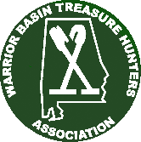
HUNT SITE IS SMITH LAKE PARK, 45 MILES NORTH OF BIRMINGHAM AND WEST OF I-65
THIS YEAR’S PRIZES: METAL DETECTOR AND TOKENS FOR OTHER VALUABLE PRIZES.
RAFFLES WILL BE HELD FOR OLD AND NEW SILVER COINS, ETC. ENJOY THE FELLOWSHIP OF OTHER TREASURE HUNTERS

SATURDAY – OCTOBER 9th
7:00 A. M. – 7:45 A. M. | REGISTRATION AND TALL TALE TIME, ETC.:
8:00 A. M. - 9:00 A. M. | SILVER BONANZA: THIS HUNT WILL CONSIST OF AN ASSORTMENT OF SILVER ITEMS FROM SILVER QUARTERS ON UP.
9:30 A.M. – 10:30 A.M. | DOLLAR BILL HUNT: HUNT WILL CONSIST OF PAPER MONEY BURIED WITH METAL TARGETS AND $1 COIN WILL ALSO BE IN THE FIELD.
11:00 A. M. – 12:00 P. M. | RELIC HUNT: HUNT WILL CONSIST OF RELICS AND TOKENS FOR PRIZES
12:00 P. M. – 12:45 P.M.  1:00 P.M. – 2:00 P.M. | LUNCH BREAK: HOTDOG AND CHIPS INCLUDED IN HUNT FEE. DRINKS ARE 50 CENTS EACH.  MAIN HUNT: MAIN PRIZE BOARD TOKENS AND SILVER FOR KEEPING - TOKENS TO BE REDEEMED FOR PRIZES.
2:30 P. M. – TILL … | AWARDING OF TOKEN PRIZES: ALL THE TOKEN PRIZES WILL BE GIVEN AWAY AT THIS TIME AND FOR ALL TOKENS NOT FOUND DURING ANY OF THIS YEAR’S HUNT FIELD ACTIVITIES WE WILL DRAW HUNT PARTICIPANT BADGES AND GIVE THESE PRIZES AWAY ALSO (BUT YOU MUST BE PRESENT TO WIN).

PRIZES WILL BE WON BY DIGGING THIS YEAR’S TOKENS, ETC. THE COINS AND BURIED PRIZES THAT YOU FIND, YOU KEEP!!
THE MARKED TOKENS ARE RETURNED WHEN YOU CLAIM YOUR PRIZE
PLEASE OBSERVE ALL THE HUNT RULES….THIS WILL ASSURE A GOOD FUN HUNT FOR ALL

Directions to hunt site: Smith Lake Park
416 County Road 385
Cullman, AL 35057
From I-65 north of Birmingham Take exit 304 (Good Hope, Hwy 69)
Turn west from I-65 (CR 437) and drive about 5 miles
Turn right onto CR 813 and drive about 2 miles to a boat storage business on left. Turn left at boat storage (CR 385) and drive about 1000 feet.
You will see the park entrance from there.

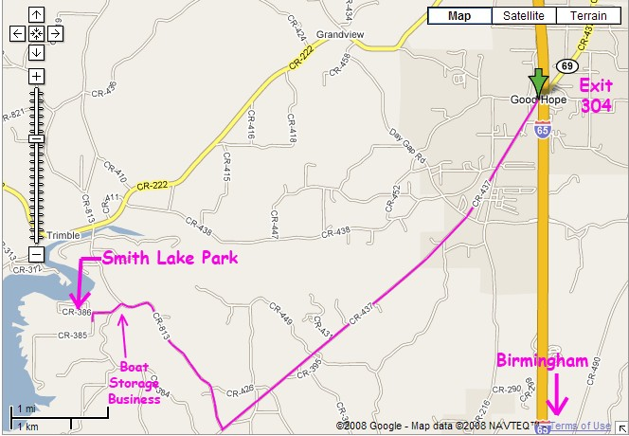
About 5 miles
About 2 miles

The two closest hotels are:

Econo Lodge – Cullman: (256) 734-2691, at Good Hope exit 304 on I-65

Days Inn – Cullman: (256) 739-3800, at Cullman exit 308 on I-65

CABINS AND CAMPING ARE AVAILABLE AT SMITH LAKE PARK FOR A FEE

TO MAKE RESERVATIONS, CALL 256-739-2916 (ENTRANCE GATE)
Discount may be available by asking about the “Treasure Hunters” rate.

AND WATCH FOR ANY CHANGES IN DATES OR DETAILS.

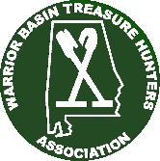
REGISTRATION FORM AND RELEASE
FOR THE WARRIOR BASIN TREASURE HUNTERS ASSOCIATION 48th ANNUAL DEEP SOUTH TREASURE HUNT
October 9th, 2021, at SMITH LAKE PARK – CULLMAN, ALABAMA

WWW.GARRETT.COM

MAKE CHECKS OR MONEY ORDERS PAYABLE TO: WARRIOR BASIN TREASURE HUNTERS ASSOCIATION
USE ONLY ONE (1) ENTRY FORM PER PERSON - MACHINE COPIES ARE ACCEPTABLE.

NAME:

ADDRESS: E-Mail:

CITY: STATE: ZIP: PHONE: ( )

CHECK THE HUNTS YOU WISH TO ENTER:

SILVER BONANZA DOLLAR BILL RELIC MAIN ALL

→ HEADPHONES REQUIRED - ONLY SMALL DIGGING TOOLS –
NO HOES - NO SHOVELS – NO RAKES - NO PULSE MACHINES ←

BY SIGNATURE BELOW I SIGNIFY THAT I AM SOLICITING ANY PRIZE I MAY WIN. FURTHER, I WILL BE RESPONSIBLE FOR ANY TAXES THAT MAY BECOME DUE AS A RESULT OF MY ENTERING THIS HUNT INSOFAR AS THE VALUE OF PRIZES OR THE MONEY I MAY WIN IN THE EVENTS. FURTHER I RELEASE ANY PHOTOGRAPHS OF MYSELF FOR JOURNALISTIC PURPOSES CONCERNING THIS HUNT AND HOBBY IN GENERAL. FURTHER I RELEASE ALL SPONSORS, INDIVIDUALS AND THE CULLMAN COUNTY PARK BOARD FROM ANY CLAIMS DUE TO LOSS, ACCIDENTS, FIRE, THEFT, OR PERSONAL INJURIES.

SIGNATURE: DATE: (PARENT OR GUARDIAN MUST SIGN IF UNDER 18)

2021 FEE SCHEDULE: HUNT ENTRY FEES - IF RECEIVED BY CUTOFF DATES AS SHOWN BELOW:
VERY IMPORTANT
 | ENTRIES RECEIVED ========> | FROM 5/1/21 THRU 6/30/21 | FROM 7/1/21 THRU HUNT DATE
 | SILVER BONANZA HUNT | $75 | $85
 | DOLLAR BILL HUNT | $20 | $30
 | RELIC HUNT | $25 | $35
 | MAIN HUNT | $90 | $105
 | ALL HUNTS | $200 | $250

NOTE
DO NOT MAIL IN REGISTRATION AFTER 9/30/21.

REGISTER AT HUNT SITE ONLY!

BEST DEAL
REMIT ONLY BY CHECK OR MONEY ORDER (NO CASH, PLEASE) TO: TOTAL ENCLOSED: $
MAIL IN YOUR ENTRY TODAY TO: WARRIOR BASIN TREASURE HUNTERS ASSOCIATION
190 BRANDY LANE
MULGA, AL 35118

-- MAIN HUNT ENTRIES RECEIVED BY 6/30/21 WILL RECEIVE A TICKET IN THE DRAWING FOR A FREE MAIN HUNT FOR NEXT YEAR.

SORRY, BUT NO REFUNDS AFTER 9/01/2021

IF YOU HAVE ANY QUESTIONS OR NEED FURTHER INFORMATION CALL: DAVID SCALES (205) 529-8955 or JOE BOX (205) 451-7693 or LAWRENCE MCKELVEY (205)283-0099
OR E-MAIL A WBTHA MEMBER AT:
Ds5584@aol.com OR ulozifindjoe@gmail.com OR lmckelvey1329@charter.net
VISIT OUR WEBSITE AT WBTHA.COM

